Subscribe Event From IAP
Assets Management System
Author: John Li
Last Updated: 03/18/14

Executive Summary
This document specifies when the AssetManagementSystem(AMS) want to receive the message from PMS then AMS need subscribed event from IAP and analyze the message sended from the PMS

1. Subscribe event from IAP
http://192.168.4.49:8080/AdminConsole/listApplications.do
(Need admin role to login AdminConsole).

1. Register a event for a app. Below is PMS's add event page.

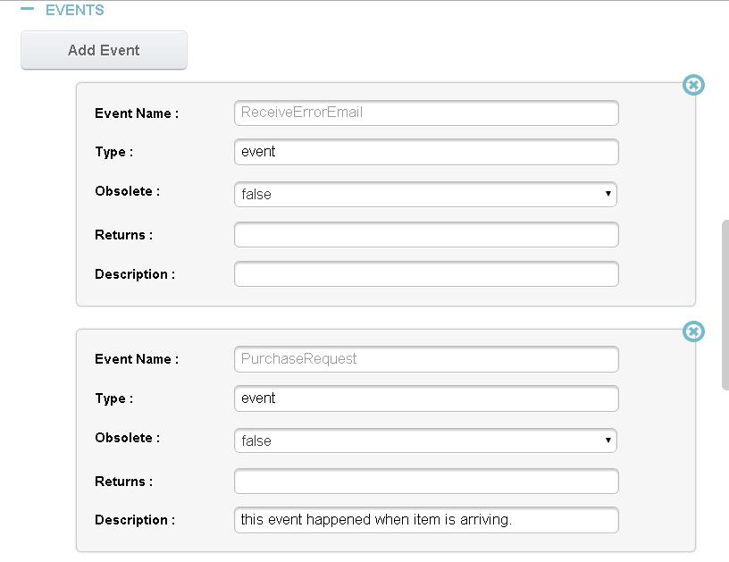

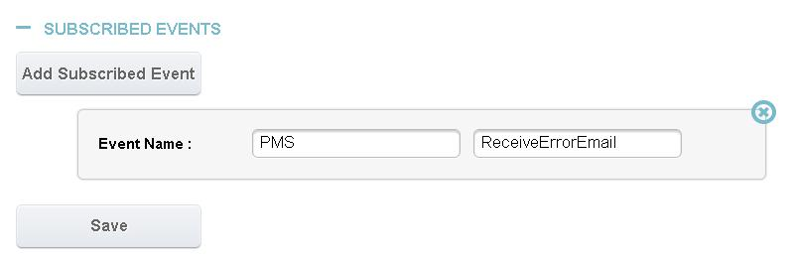
- Subscribed events. Just choose APP name and event name.

2. Configuration of the web.xml

Add “authenticatedUrl” into the CAS Authentication Filter
web.xml
<filter>
<filter-name>CAS Authentication Filter</filter-name>
<filter-class>
com.augmentum.iaphelper.filter.AuthenticationFilter
</filter-class>
<init-param>
<param-name>authenticatedUrl</param-name>
<param-value>/AssetManagement/callbackEntry</param-value>
</init-param>
</filter>

3. Implement the “/callbackEntry” controller

package com.augmentum.ams.web.controller.home.HomeController

@SuppressWarnings("unchecked")
@RequestMapping("/callbackEntry")
public void callbackEntry(HttpServletRequest servletRequest) throws
SystemException {

logger.info("get in callbackEntry method");
String requestBody = null;
try {
requestBody = new RequestHelper().getRequestBody(servletRequest);
logger.info("get request body successful");
} catch (IOException e) {
throw new SystemException(e, ErrorCodeUtil.SYSTEM_ERROR, "get
message error from PMS");
}
// convert JSON String to Message Object
Message message = JsonUtils.convertJsonToMessage(requestBody);
if (message != null) {
if ("PMS_PurchaseRequest".equals(message.getName())) {
logger.info("get message successful");
// purchaseItemService.createPurchaseItem(message);
JSONObject object = JSONObject.fromObject(message.getBody());
Map<String, Object> dataMap = (Map<String, Object>)
object.get("request");
purchaseItemService.createPurchaseItem(dataMap);
} else {
logger.info("this message not come from PSM");
}
}
}

4. Analyze the data from the PMS

package com.augmentum.ams.service.asset.impl.PurchaseItemServiceImpl

@SuppressWarnings("unchecked")
@Override
public void createPurchaseItem(Map<String, Object> dataMap) {

String processType = null;
String dataSite = null;
String entitySite = null;
Date deliveryDate = null;
int finalQuantity = 0;

List<Map<String, Object>> orderList =
(List<Map<String, Object>>)dataMap.get("orders");

for (Map<String, Object> orderMap : orderList) {
List<Map<String, Object>> itemList =
(List<Map<String, Object>>)orderMap.get("items");

for (Map<String, Object> itemMap : itemList) {
PurchaseItem purchaseItem = new PurchaseItem();
purchaseItem.setPoNo(CommonUtil.objectToString(orderMap
.get("poNo")));

processType =
CommonUtil.objectToString(dataMap.get("processType"));
if ("NO_CHARGE_IT".equals(processType) ||
"NO_CHARGE_NON_IT".equals(processType)) {
processType = SystemConstants.AUGMENTUM;
}
if ("CHARGE_NEED_COFIRM".equals(processType) ||
"CHARGE_CONFIRMED".equals(processType)) {
processType =
CommonUtil.objectToString(dataMap.get("customerName"));
}
purchaseItem.setProcessType(processType);

if("SOFTWARE".equals(CommonUtil.objectToString(
itemMap.get("itemType")))){
purchaseItem.setItemType(AssetTypeEnum.SOFTWARE.name());
}
if("HARDWARE".equals(CommonUtil.objectToString(
itemMap.get("itemType")))){
purchaseItem.setItemType(AssetTypeEnum.MACHINE.name());
}
if("OTHERS".equals(CommonUtil.objectToString(
itemMap.get("itemType")))){
purchaseItem.setItemType(AssetTypeEnum.OTHERASSETS.name());
}
purchaseItem.setCustomerName(CommonUtil.objectToString(
dataMap.get("customerName")));

purchaseItem.setCustomerCode(CommonUtil.objectToString(
dataMap.get("customerCode")));

purchaseItem.setProjectName(CommonUtil.objectToString(
dataMap.get("projectName")));

purchaseItem.setProjectCode(CommonUtil.objectToString(
dataMap.get("projectCode")));

purchaseItem.setVendorName(CommonUtil.objectToString(
orderMap.get("vendorName")));

purchaseItem.setItemName(CommonUtil.objectToString(
itemMap.get("itemName")));

purchaseItem.setItemRealName(CommonUtil.objectToString(
itemMap.get("realName")));

purchaseItem.setItemDescription(CommonUtil.objectToString(
itemMap.get("description")));

dataSite = CommonUtil.objectToString(dataMap.get("dataSite"));
if ("IES_SH".equals(dataSite)) {
dataSite = "Augmentum Shanghai";
}
if ("IES_BJ".equals(dataSite)) {
dataSite = "Augmentum Beijing";
}
if ("IES_WH".equals(dataSite)) {
dataSite = "Augmentum Wuhan";
}
if ("IES_YZ".equals(dataSite)) {
dataSite = "Augmentum Yangzhou";
}
purchaseItem.setDataSite(dataSite);

entitySite =
CommonUtil.objectToString(orderMap.get("entitySite"));
if ("QSSH".equals(entitySite)) {
entitySite = EntityEnum.QunshuoShanghai.toString();
}
if ("QSBJ".equals(entitySite)) {
entitySite = EntityEnum.QunshuoBeijing.toString();
}
if ("QSWH".equals(entitySite)) {
entitySite = EntityEnum.QunshuoWuhan.toString();
}
if ("QSYZ".equals(entitySite)) {
entitySite = EntityEnum.QunshuoYangzhou.toString();
}
purchaseItem.setEntitySite(entitySite);

if (!StringUtils.isEmpty(
CommonUtil.objectToString(orderMap.get("deliveryDate")))) {
deliveryDate =UTCTimeUtil.localDateToUTC(
CommonUtil.objectToString(
orderMap.get("deliveryDate")));
}
purchaseItem.setDeliveryDate(deliveryDate);

if (!StringUtils.isEmpty(
CommonUtil.objectToString(
itemMap.get("finalQuantity")))) {
finalQuantity = Integer.parseInt(CommonUtil
.objectToString(itemMap.get("finalQuantity")));
}
purchaseItem.setFinalQuantity(finalQuantity);

purchaseItem.setUsed(false);
logger.info("AMS get callback : " +
dataMap.get("customerName"));
logger.info("get request body successful" +
purchaseItem.getCustomerCode() +
purchaseItem.getCustomerName());

purchaseItemDao.save(purchaseItem);
}
}
}

